Dr Ian Watson

Marta Cecchinato

A Staff/Student Tutorial Booking System

Software Engineering Project

Sean Pattinson  
16004894  
Computer Science with Web Development

Project Terms of Reference

KV6003: Individual Computing Project

# Project Title

Staff and Student Tutorial Booking System

# Background to Project

The product that I am going to produce for my final year project is a web based application that allows Student’s to book a tutorial session with a member of staff, this will either be created from the ground up or via modifying existing open source solutions that are readily available. The problem domain I will be working in will be online booking systems, although the system I am developing could be repurposed for other domains that would use a similar functionality, for example an IT support company could use it to book technicians out for scheduled repairs or investigation rather than arranging it through the likes of email. The general features of the booking system will include entry and storage of a schedule in a datatype that can be called back to show as a date and time format, the system should also feature the ability for students to book a time slot with the tutor using the schedule provided, upon booking the system should send both the tutor and tutee email invite with a calendar item to add to their calendars. The system should also feature some way that group bookings can occur so some research into how these would be handled should be looked into, another key feature that the system should implement is reminders of the booking should be sent to the parties that are involved in the booking I will need to research the best feasible way to implement this feature as it is something that I have not dealt with previously.

Some of the issues that I will need to cover in my literature review to ensure I understand how to build the full functionality required of the system will include researching the best or most efficient way to manage the sending of email reminders to the parties involved in the tutorial booking as this will most likely require the use of cron jobs or something similar, although upon completing my literature review I may find a more efficient way to implement this functionality. I will also need to research an effective way to store the schedules provided by staff members so that they can be recalled by the system and be displayed when a student requests to book a tutorial with a staff member as it may be better to store them in a noSQL database rather than a relational database. During my literature review I should also research a way that calendar invites could be generated in order to be sent to the parties involved in the tutorial booking. In my literature review I should also cover some aspects of UX design to ensure a positive and intuitive user experience when using the system as if the system is not easy to use and its purpose is not clear to an end user then there would be push back on the integration of the system due to it not being easy to use it would also be a good idea to cover some aspects of UX design in my literature review as it could broaden my own personal knowledge and allow me to incorporate better design practices when creating user interfaces in future systems as well as during this project. It would also be beneficial to research alternate design practices when it comes to the accessibility and inclusivity of the application as this would ensure that the system would be accessible and usable by a wider audience.

I feel the project is viable especially because of its nature being based around booking appointments as we are in an ever evolving digital world especially now thanks to the events of this year companies could utilize booking systems to offer a multitude of services obviously not just focusing on the booking of tutorials as a tool for teaching this would be looking at a larger audience from a business perspective where the system could be built somewhat modularly to allow simple modifications to a clients need or the project could provide the knowledge and expertise to provide similar systems to clients requiring some kind of booking or appointments services. More and more so as we progress further into the 21st century we are offered a multitude of online services compared to our forefathers we now have the ability to book flights online, book hotels online, book tables at restaurants online (e.g Nandos, Toby Carvery, Miller and Carter) this is due to an ever-growing digital society and has become “normal” (Kaushik, Agrawal and Rahman, 2015). These are what you would call self service technologies as it does not require interaction with another person so to speak it can all be done with the click of a button.

The project is of interest to me personally as if my placement had lasted the full period it was supposed to then some of the work I would have undertaken would have been somewhat similar to this project that was one of the supervisor ideas, this instantly drew me to this idea as I recalled it being discussed by my work based supervisor although the system would not have been identical it would have been something similar to an application that I would have built on placement, I also believe if I client was to approach myself with a similar project idea it is a system that could be somewhat flexible if it is built more modularly and this would allow it to be modified to fit multiple clients purposes. Some of the problems ill need to solve when building the system will be mostly covered in my literature review, some of the main issues will be tied to sending automated emails to all required parties of the booking as this would be something that I have never done before so this would require me to research the most practical ways in order to send these automated emails, I also actually believe one of my biggest challenges or problems going into the project will be deciding between currently available open source software and performing extensive modifications or if a completely bespoke system would be the best approach to the project. Some of the open source options that are currently readily available that could be modified to create the system required include easy appointments which is an open source software developed by Alex Tselegidis this has features already built in that support multiple person bookings but as far as I’m aware currently only supports connections of google calendars, while this would be a good base for my application I feel that it may already be too established and would take away from the challenge of building the system if some of the more difficult aspects are already taken care of. Another option of open source software I would have is classroom bookings now this would require extensive modifications to the existing application in order for it to fit the requirements and spec of the system I am trying to build. I will also need to investigate the best way that the storage of the schedules can be managed for them to be recalled and presented in a calendar so they can be booked by students. I will also have to investigate the best way that a calendar invite for the meeting can be generated and emailed over to the respective parties.

# Proposed Work

I will be building my own web application or modifying existing open source software to create a Student/Staff tutorial booking system the application will be built using a mixture of HTML/PHP combined with SQL for the database for the storage and retrieval of information such as staff schedules and created appointments, the system will feature functionality for a tutor to add a schedule or hours available via a calendar which will be stored in an MySQL database so that it can be recalled and displayed when a student wants to book a tutorial with the corresponding tutor, the tutors should also be able to update or amend their schedule rather than creating a whole new schedule each time there needs to be a modification to the schedule. The application also needs to allow either staff and students to be able to add a preferred contact email that the invites and reminders will be sent to, therefore I need to look into some kind of data governance and security as if I am storing personal information like emails I need to ensure that the application is secure and the best security practices to ensure there won’t be any breach of confidentiality or data. I will need to research some aspects of UX design in my literature review this will help the project as it will ensure that a clean and clear user interface is created when developing the app as well as employing good user experience design practices, I should also investigate best practices for building a web app when I am doing my literature review as I want to ensure the best practices are undertaken when designing and developing the system this will ensure the best practices when coding the system and ensure the lack of redundant code and functions in the application code, during my literature review I will also investigate some of the open source software alternatives that are available for appointment scheduling to see if there are any that offer a solid and clear to modify software that can be extensively modified to fit the purpose of the system I am building, this will allow me more to focus on building a more functional system on a robust framework than worrying about having to build a strong framework from scratch and then incorporating further functionality. I will also need to research how to generate an .ics or .ical file so I can send the invite to the parties involved in the booking. The computing technologies that will be included in the building of the project will be HTML, PHP 5.6, MySQL as well as some form of webserver whether it be nginx or apache as I may need access to install other packages on the server that would not be available to me if using newnumyspace as far as I am aware.

# Aims of the Project

To build a web based staff/student booking system that allows group bookings, send email invites and reminders and allows tutors to upload a schedule via a calendar.

# Objectives

1. Review topics noted previously during literature review to ensure knowledge required is gained to undertake the project.
2. Create a requirements specification for the online booking system.
3. Enhance current knowledge by conducting further research on best design practices on building web based applications.
4. Create designs for User Interface and general aesthetics of booking system.
5. Create Use Case Diagrams for student, staff/lecturer and admin for booking system.
6. Create Entity relationship diagram for SQL database used in project.
7. Create back end framework for web application ensuring all functionality required is accounted for.
8. Build front facing aspects of web application and implement design and styling to web application.
9. Allow user testing of booking system to ensure any issues identified and remedied before final version.

# Skills

* Knowledge of object-oriented PHP development practices and creating a strong back end framework as well as other web application languages such as HTML and JavaScript – Familiar, experience gained on a year out in placement as well as via module KF6012 Web Application Integration
* Knowledge of SQL database creation modification and manipulation via MySQL – Familiar – Learned from various different web based modules such as KF6012 Web Application Integration as well as web development modules during my 1st and 2nd years of study as well as relational databases in my 1st year of study.
* Knowledge of HCI practices and best practices to implement a solution that has a strong emphasis on HCI to ensure application is usable and accessible via a wide audience – New/Enhanced – Briefly touched in Human Computer Interaction module studied in year 2 but will need to research this further to identify best practices and things to take into consideration this will be enhanced through the use of the literature review by identifying academic articles on the subject and identifying good practices and principles on the design of a web based application related to HCI.
* UX design principles and best practices to create a good user experience when using the app – New, this will be gained by academic reading on UX design during the literature review during the project.
* Knowledge of email schedulers to send email reminders to involved parties – New Skill, I will have to research this aspect as I know there is the likes of CRON and windows scheduler that can do this but I will need to research the most efficient way to cover this functionality of the system during my literature review.

# Sources of Information/Bibliography

Kaushik, A., Agrawal, A. and Rahman, Z., 2015. Tourist behaviour towards self-service hotel technology adoption: Trust and subjective norm as key antecedents. *Tourism Management Perspectives*, 16, pp.278-289.

# Resources (Hardware/software required)

## Software

* PHPStorm – provided via educational license tied to university email account.
* XAMPP – open-source cross-platform web server solution stack package developed by Apache Friends available from <https://www.apachefriends.org/download.html>, used to test web application on local environment and develop locally before deploying
* PHP Version 5.6 – Available from <https://www.php.net/releases/index.php>, this will be used on development server as this is the PHP environment I am familiar with.
* MySQL – used for the database that information will be stored in, available free at <https://www.mysql.com/>
* Bootsrap (Optional) – I’ve listed this as I am not yet sure if I will use it so its better to include it than not, this will be used for styling and icons of the web application as they offer a nice library of SVG icons that could be used as well as some other aspects that the application may use, it’s an open source software that is available for free from <https://getbootstrap.com/>
* GNU Image Manipulation Program – This will be used to create prototype/exoskeleton designs of the web application UI as well as any logo designs or other graphics required, it’s an Open source graphics editor that is free to download at <https://www.gimp.org/>
* Github – This will be used for version control and back ups of the project to mitigate potential loss of data if there are any issues with my personal machine.

## Hardware

* PC to develop web application on – This will be provided by myself, I will be using XAMPP on my personal machine to develop the application before deploying onto a web server.
* Apache/Nginx web server – This will be funded by myself, I believe this will be needed as I may need to install additional dependencies on the web server and I believe it would not be possible for me to do this via newnumyspace.
* USB Drive – Provided by myself, this will be needed to submit evidence files as part of the project and may also be needed during the viva to transfer web application onto lab machine to run on local development server to demo the application.

## Alternatives

* Sublime text editor – Alternative software to PHPstorm should my license not be valid, its an shareware text editor that is available from https://www.sublimetext.com/ and can be used as an alternative to PHPStorm if I am unable to verify ownership of a valid PHPstorm license.
* MAMP – Alternative to XAMPP, should XAMPP be unavailable I will use MAMP as an alternative as it is a free software that should have similar functionality to XAMPP available at <https://www.mamp.info/en/windows/>
* PHP Version 7.4 – If I am unable to obtain PHP version 5.6 I will look to use PHP Version 7.4 as I have developed using PHP 7.4 during my placement so have some workable knowledge of this version.
* MariaDB – Alternative to using MySQL, MariaDB is very similar to MySQL so should MySQL not be available I will use MariaDB which is an open source database software.

# Structure and contents of project report

## Report Structure

### Abstract

### Introduction

* Discuss the aims and objectives of the project briefly and explain what they mean.
* Overview of built product – give purpose, scope main features and characteristics
* Reasoning for undertaking the project
* Approach to the project and tools used

### Analysis

* Literature review – links to objectives 1 and 3
* Commentary on key points in requirements specification – Links to objective 2

### Synthesis

* Discussion of analysis models – Links to objective 5
* Design Specifications – Links to objectives 4, and 6.
* Product code – Links to objectives 7 and 8.
* Testing techniques – Links to objective 9.
* Approach to testing – Links to objective 9.

### Evaluation

* Evaluation of created product
* Evaluation of the project process

### Conclusion and Recommendations

* Conclusion.

## List of Appendices

1. Requirements Specification
2. User Interface Design Documents (Storyboards)
3. Entity relationship diagram
4. Use Case Diagrams
5. Source code for application
6. Source code for database
7. Test Plans
8. Test Results

# Marking Scheme

## Project Type

This is a Software Engineering Project so I will be using the Software Engineering Project Marking Scheme.

## Project Report

### Abstract

### Introduction

* Discuss the aims and objectives of the project briefly and explain what they mean.
* Overview of built product – give purpose, scope main features and characteristics
* Reasoning for undertaking the project
* Approach to the project and tools used

### Analysis

* Literature review
* Commentary on key points in requirements specification

### Synthesis

* Discussion of analysis models
* Design Specifications
* Product code
* Testing techniques
* Approach to testing

### Evaluation

* Evaluation of created product
* Evaluation of the project process

### Conclusion and Recommendations

* Conclusion.

## Product

* Finished Web Application
* Requirements Specification
* UI Design Documents (Story Boards)
* Entity Relationship Diagram
* Use case diagrams
* Test plans and results

## Criteria

### Fitness for Purpose

* Meeting of Requirements as identified during project.
* Quality of functionality.
* HCI.

### Build Quality

* Requirements specification and analysis
* Design specification
* Code quality
* Test plans and results

# Project Plan – Schedule of Activities

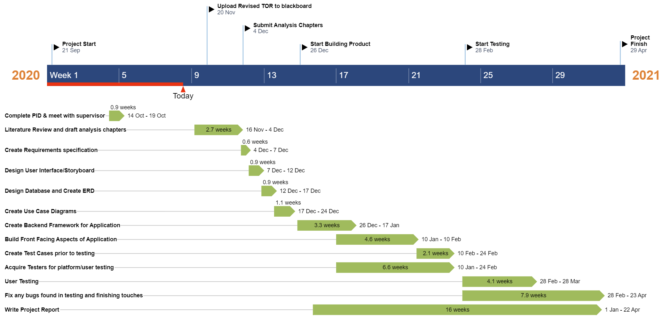

1. A staff/Student tutorial booking system
2. This is a software engineering project. It would either
3. build from scratch in HTML/SQL/PHP or
4. involve extensive modifications of open source software
5. Build a booking system where the tutor can enter in hours of available (via a calendar)
6. Students could then book the tutor
7. The tutorial could be selected for 20,30,45,hour intervals
8. Both student and tutor are sent emailed invites
9. Reminders are sent to the student and tutor
10. Group bookings might also occur.